Technical Support Guide for
Tech-ni-Fold’s Quad-Creaser
to fit the Horizon BQ-470 Binder

Please enlist the help of a trained engineer for the installation of the Tech-ni-Fold Quad-Creaser tool for the BQ-470 machine.
This support guide covers additional advice if the following problems are experienced after product installation:
- You are experiencing difficulty achieving a defined crease on heavier weight stocks of over 300gsm;
- The machine stops when the cover stock meets the first set of shafts;
- Reduction of speed as the cover enters the creasing shafts.
In our experience of installing these Quad-Creasers for the Horizon BQ-470 Binding Machines in the United Kingdom, we have come across 2 instances where the above issues were proving problematic.
After extensive research and testing, our technicians have devised the following steps to eliminate these operating issues so that the Quad-Creaser can perform as we promise.
The Problem
It eventually became apparent that the top creaser shaft is sheet-driven, situated on a free-spinning bearing. Therefore, not being driven by a motor was the problem. This sheet-driven shaft when overloaded with pressure stops the machine operating. When anything heavier than a 300gsm weighted cover stock impacts the support rollers the machine struggles to cope under the pressures involved.
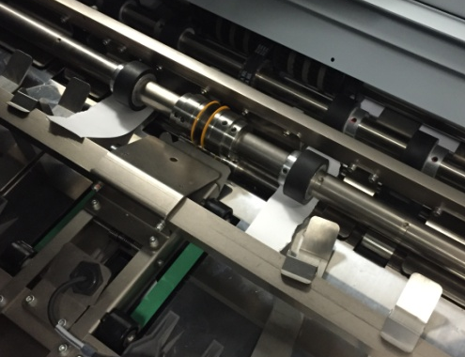
The Solution – Setting the machine to crease 300gsm cover stocks and above
1.
After installation of the Quad-Creaser, remove the outer pair of existing support rollers from the creasing shaft. Reposition inner support rollers on to the shafts using the Tech-ni-Fold supplied rollers (or using the existing Horizon support rollers, if preferred; both types will work).
Set the shaft pressures sufficiently to tightly grip a 300gsm piece of sample paper between the support rollers either side of the creasing tool. Take extra care that the pressures either side are equal.
Once you are happy that the sample material is gripped tightly enough, remove the material from the machine.

Installed BQ-470 Tech-ni-Fold Quad-Creaser with Support Rollers positioned. See the sample 300gsm material being gripped by the Support Rollers.
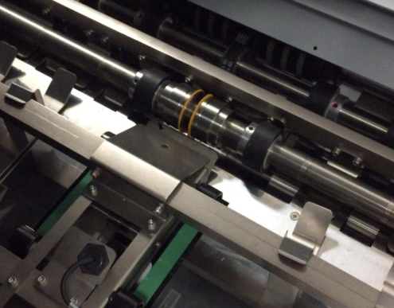
2.
Then, using the correct sized Allen Key, loosen the top support rollers on the creasing shaft. Once loosened, disengage the top rollers by simply sliding them along the shaft toward the creasing tool. When fully disengaged (i.e. the top and bottom rollers are not overlapped at all), secure the disengaged top support rollers again by tightening the shaft locking screw.
This will now allow the heavier weight cover stock to pass through the Quad-Creaser unimpeded with no reduction in speed, producing a beautifully defined crease impression in the process.

Sample material removed and top Support Rollers disengaged from the bottom rollers.

If, after following the steps provided in this guide, you are still experiencing operational problems with the creasing function in your BQ-470, then please call Tech-ni-Fold Ltd on +44 (0)1455 554491 or email info@technifold.co.uk.
There is also an accompanying video available explaining the above mentioned steps. Please ask for this over the phone or through email.
Yours sincerely,
The Tech-ni-Fold Ltd Team

